**6.2 SNAPSHOTS**

* + **Snapshot of Initial stage of the Bascule Bridge with Main Menu:**

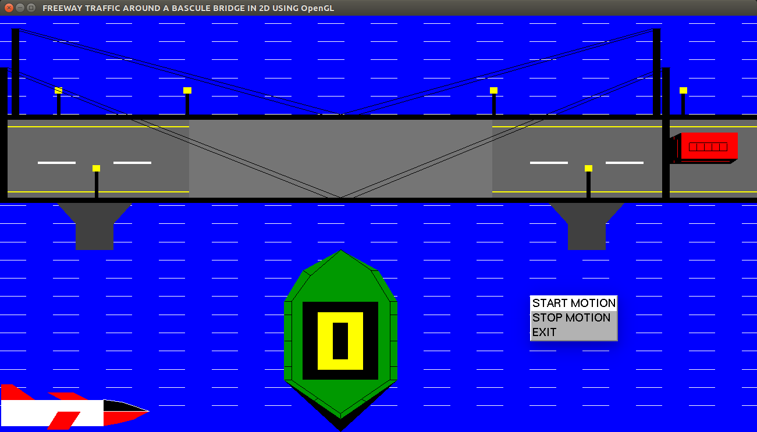

Fig 6.6 Initial Stage of Bascule Bridge with Main Menu

* + **Snapshot shows the lifting up of the Bascules**

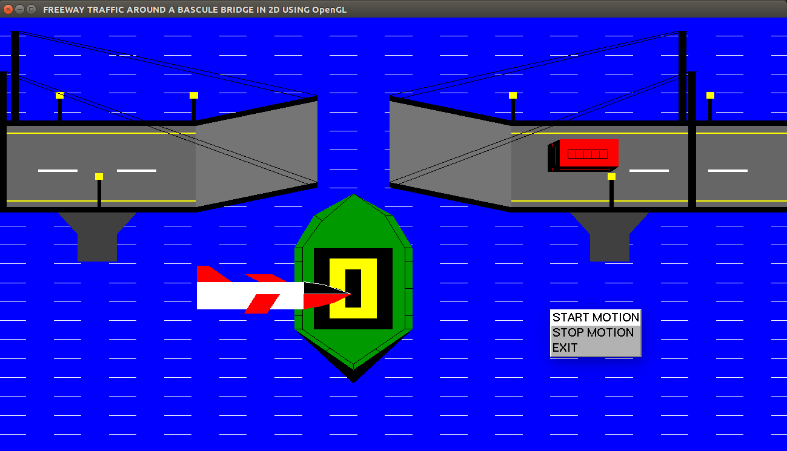

Fig 6.7 Lifting of Bascule Bridge